Bismuth Samuel 342533064

ASSIGNMENT 2 -

PART A -

Question 1, 2, 3 -
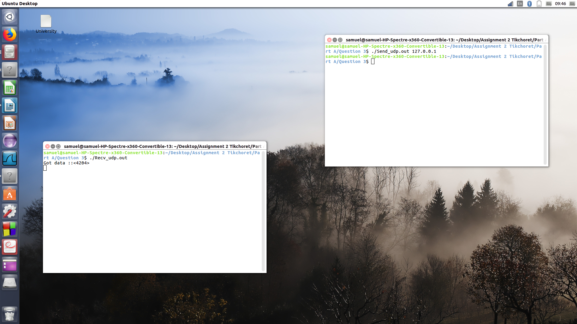
Screen-shot when running the Recv_udp and Send_udp.

As we can see, to run Recv_udp and Send_udp, we need first of all open two terminals. After running the Recv_udp code, (which contains an infinite loop), we run the Send_udp code, passing localhost as command line parameter (127.0.0.1). Then, a data is reading by Recv_udp : “Got data ::<4204>”.
Before to run the code, please refer to the README file.

Question 4 -
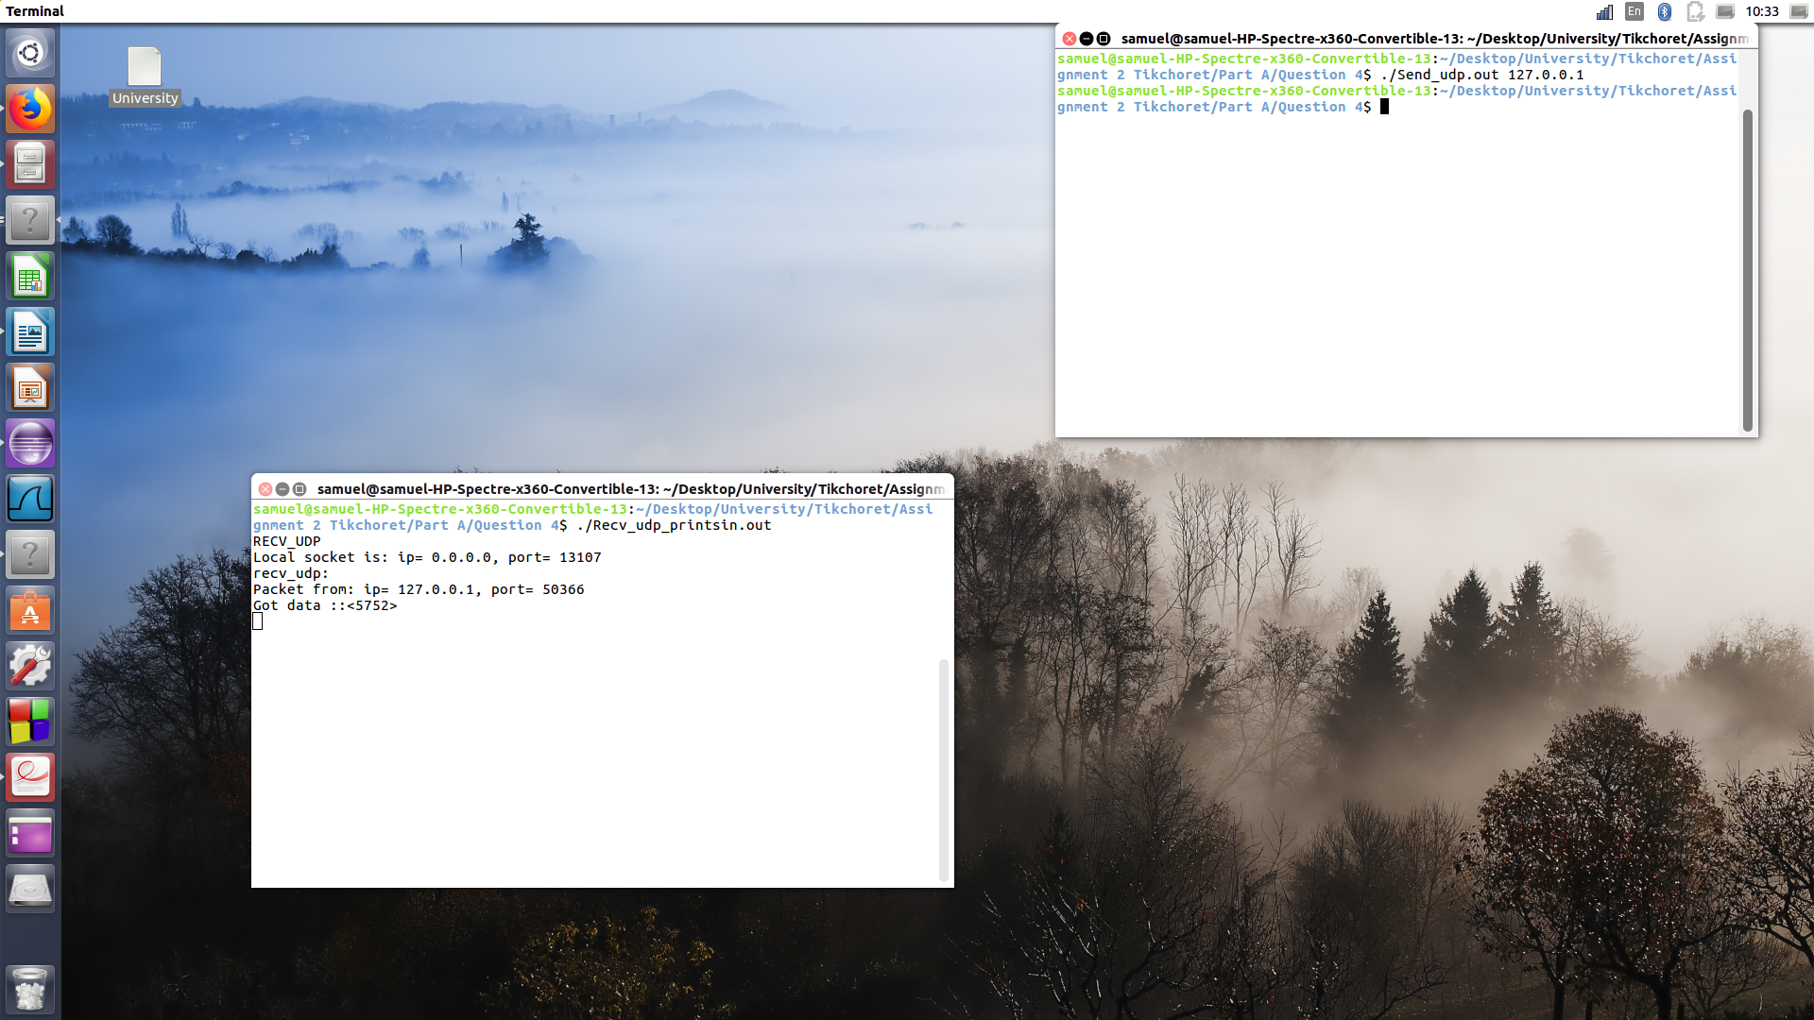
Screen-shot when running the Recv_udp_printsin and Send_udp.

As we can see, to run Recv_udp_printsin and Send_udp, we need first of all open two terminals. After running the Recv_udp_printsin code, (which contains an infinite loop), we run the Send_udp code, passing localhost as command line parameter (127.0.0.1). Then, a data is reading by Recv_udp_prinstin, especially by the function printsin :
“recv_udp:
Packet from: ip= 127.0.0.1, port= 56719
Got data ::<5995>”.
The ip is 127.0.0.1 => the localhost.
Before to run the code, please refer to the README file.

Question 5 -
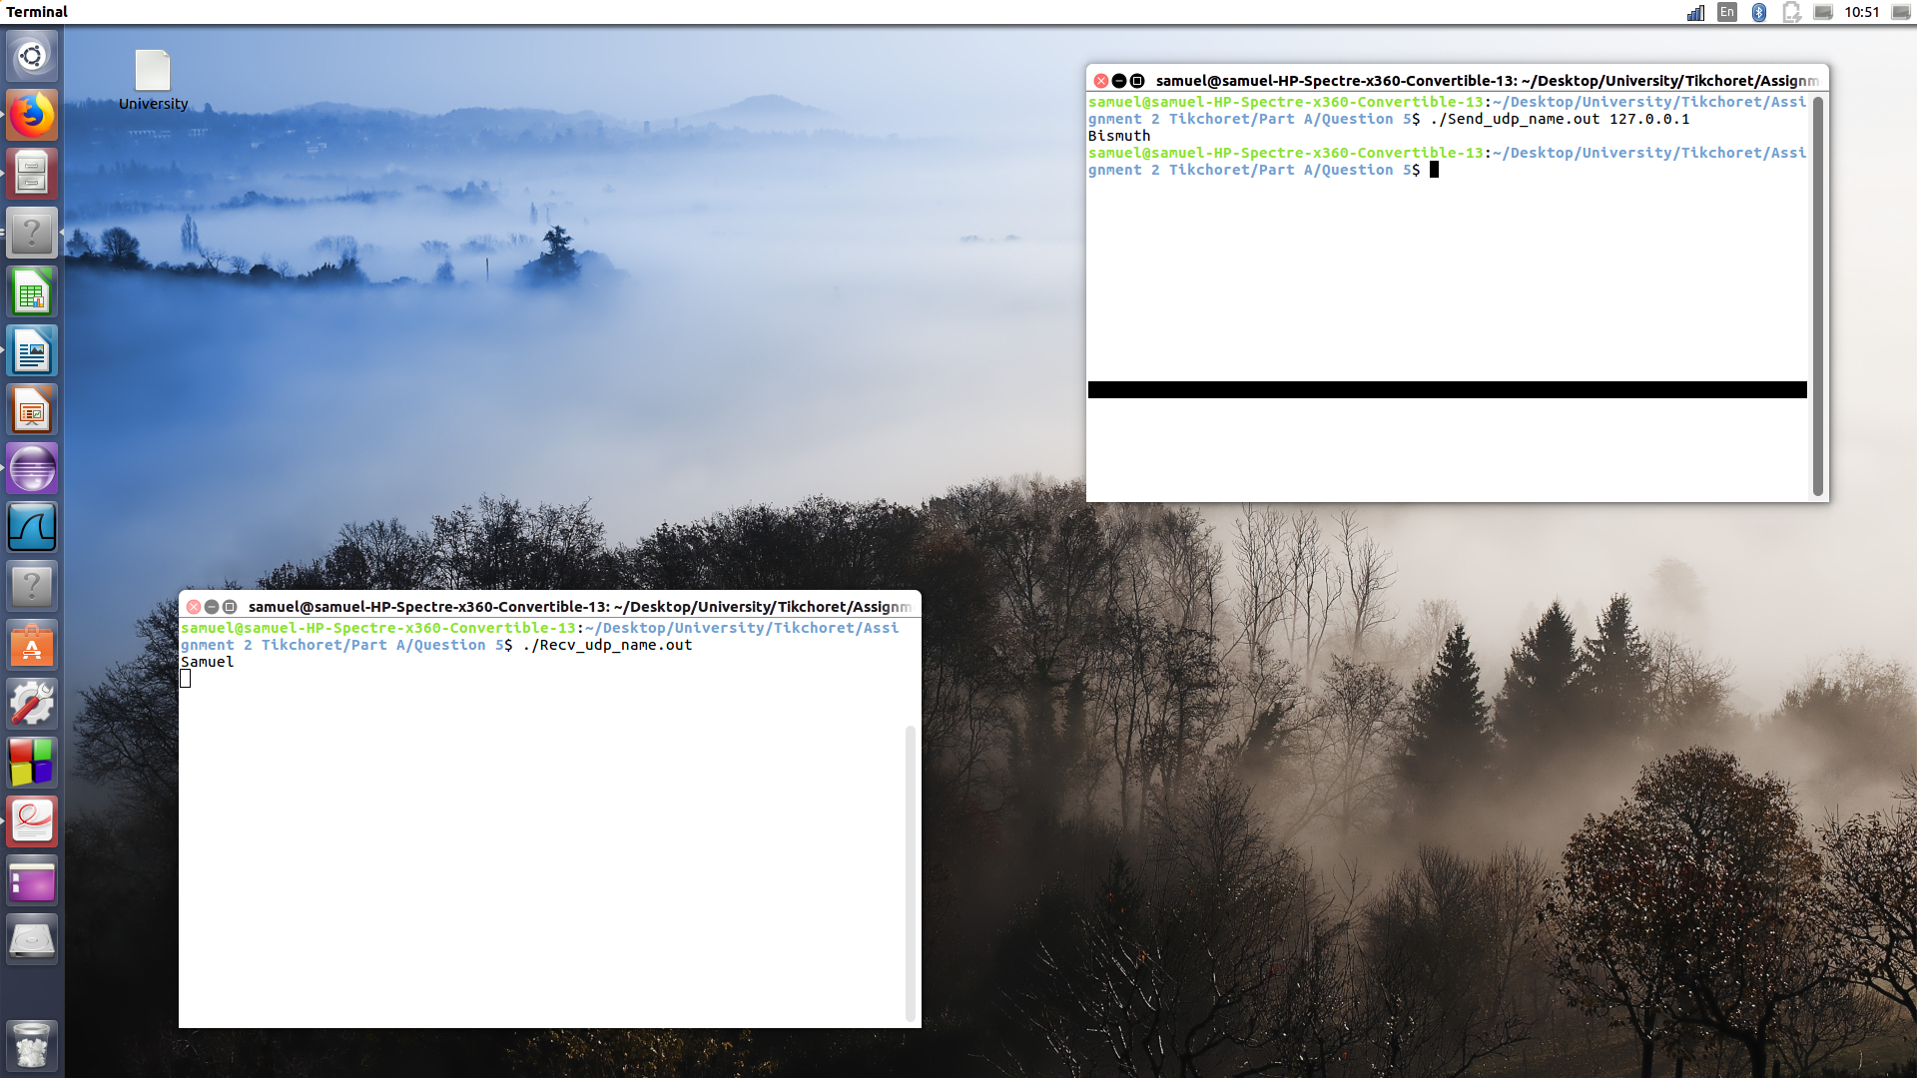
Screen-shot when running the Recv_udp_name and Send_udp_name.

As we can see, to run Recv_udp_name and Send_udp_name, we need first of all open two terminals. After running the Recv_udp_name code, (which contains an infinite loop), we run the Send_udp_name code, passing localhost as command line parameter (127.0.0.1).
Then, a data “Samuel” is reading by Recv_udp_name, and in exchange, send the data “Bismuth”, reading by Send_udp_name.
Before to run the code, please refer to the README file.

Question 6 -
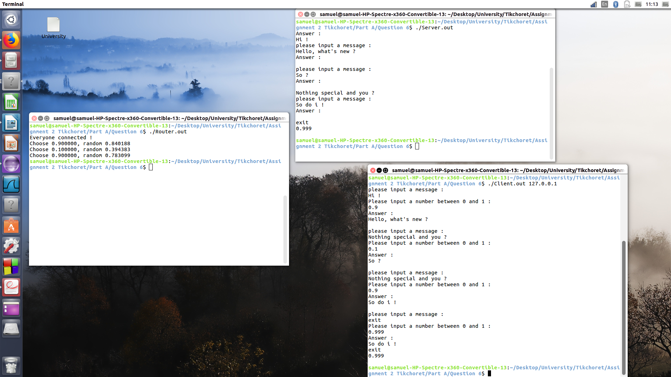
Screen-shot when running the Client , Router and Server.

As we can see, we need three terminals to run Router, Client and Server.
When the three files are connected, the Router detects the Client and Server, then, print the message “Everyone connected !”.
Then, the messages could be sended. From the Client to the Server, next, from the Server to the Client. You can send the message “exit” to quit the programs.
Before to run the code, please refer to the README file.

Part b -

I – Server – Client.

Question 2, 3 -
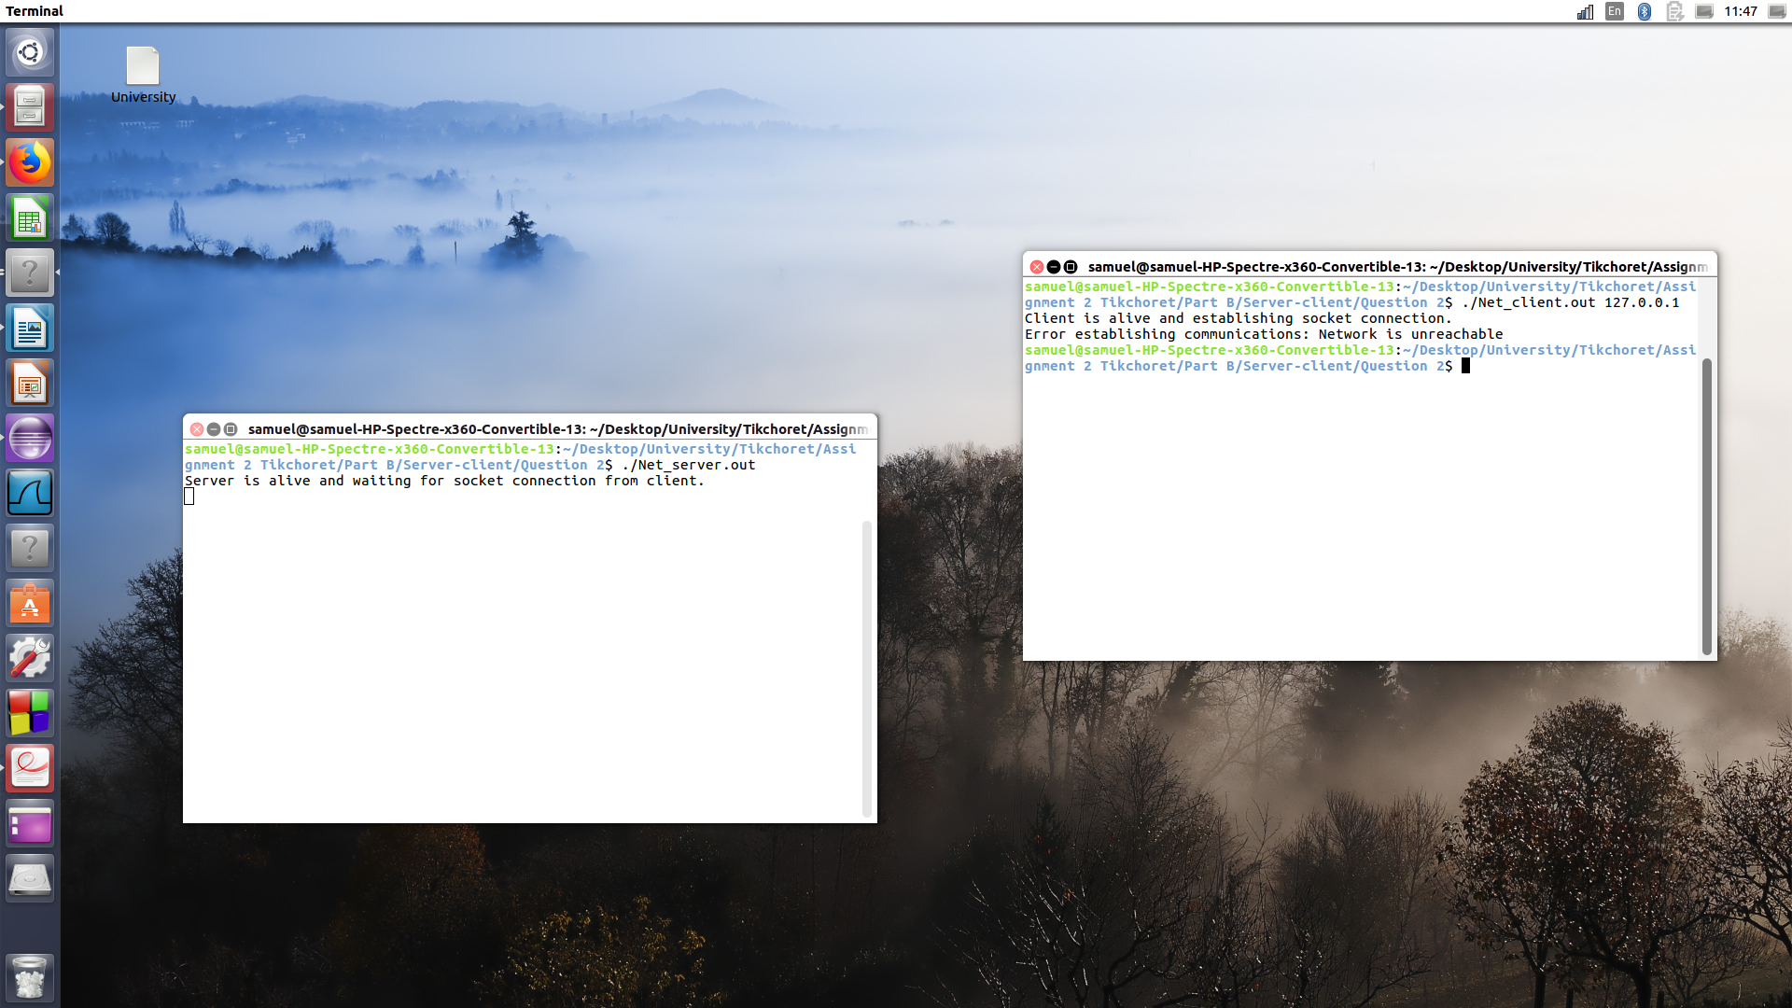
Screen-shot when running the Net_client and Net_server.

The codes are compile, but don't run as we want, an error message appears.
The programs don't run because, the IP ADRESS of the client is not configure.
Copy past from the code Net_client : #define IP_ADDRESS "?????"
Then, we got the error message as follow : Error establishing communications: Network is unreachable.
Before to run the code, please refer to the README file.

Question 4 -
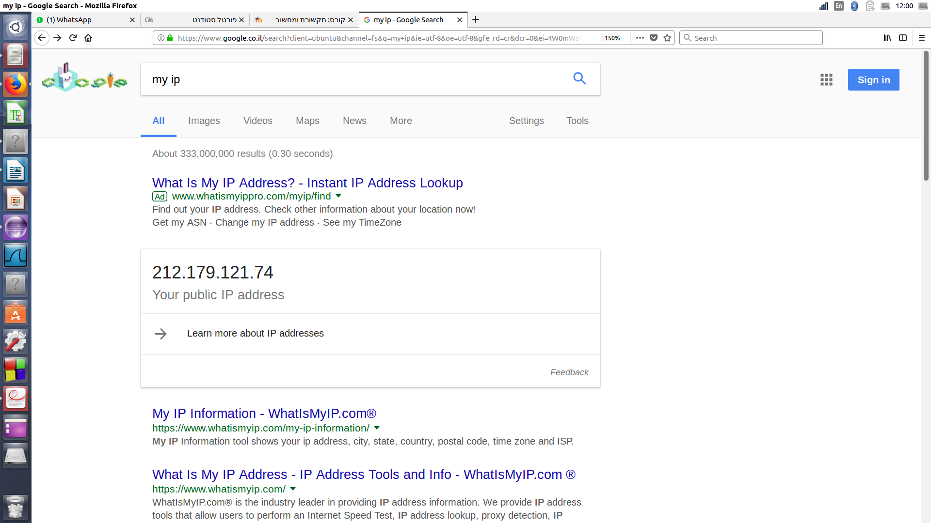
Screen-shot from google.

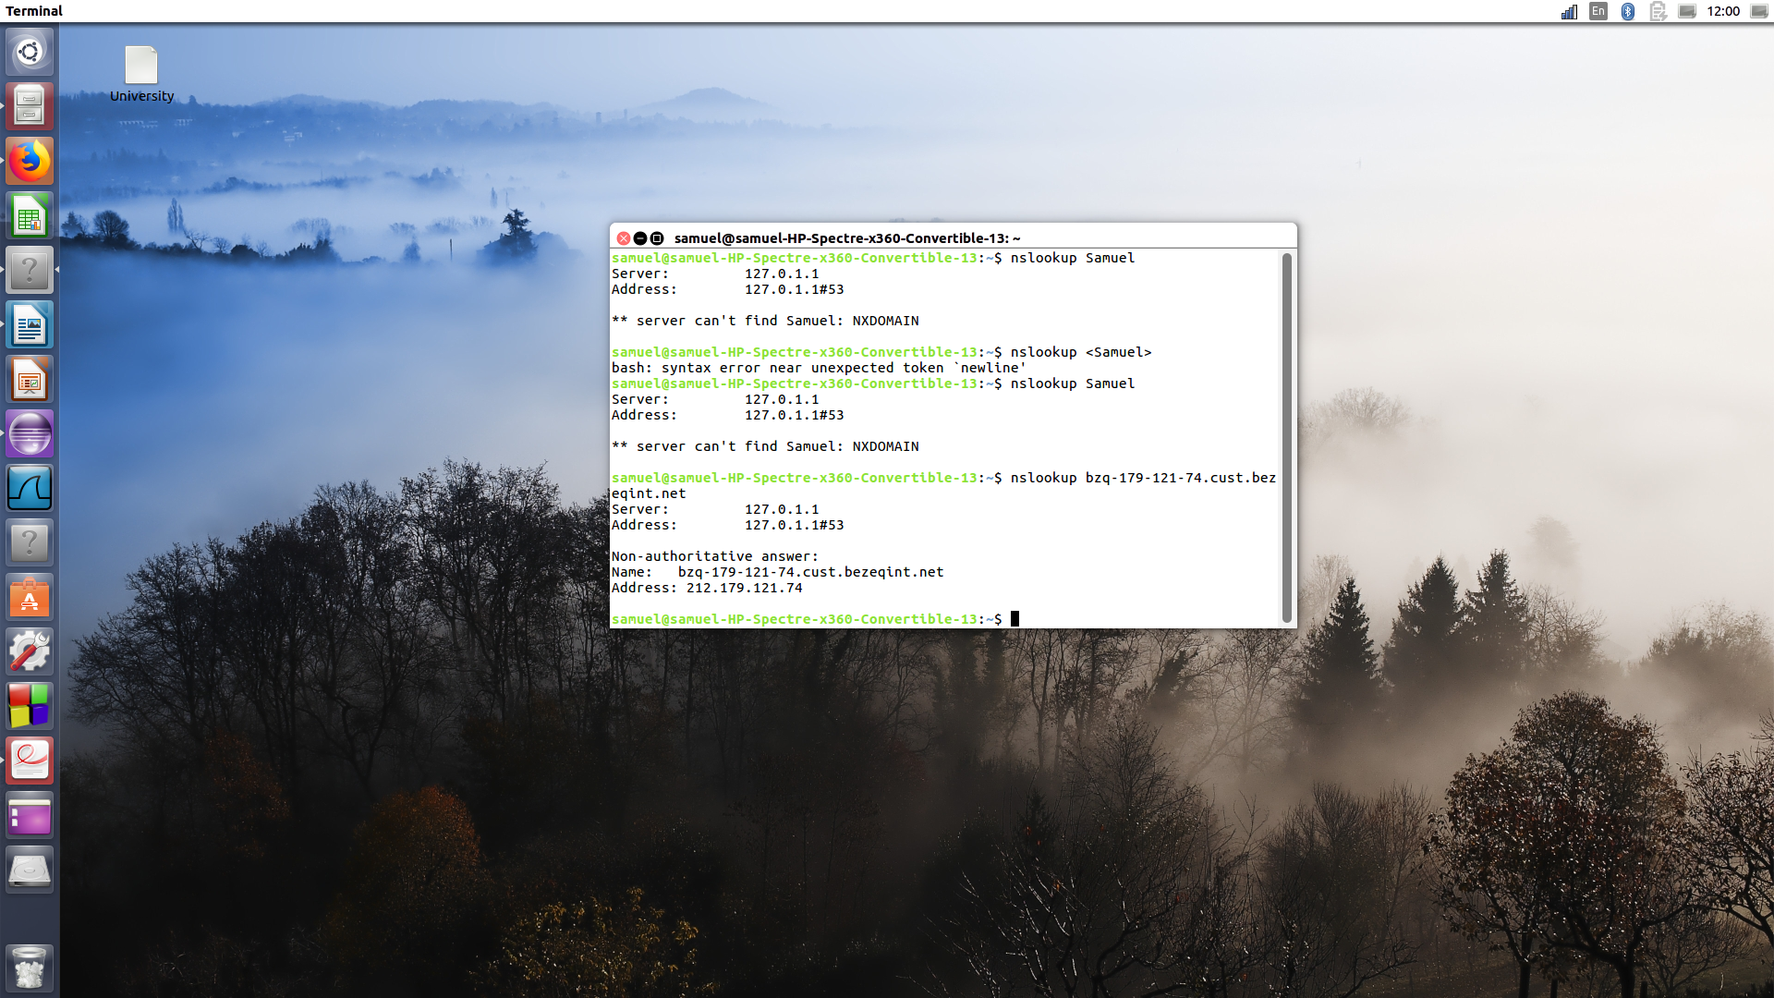
Screen-shot terminal command nslookup.

As we can see, the ip address of my computer is 212.179.121.74.
We also can use the localhost 127.0.0.1.

Question 5, 6 -
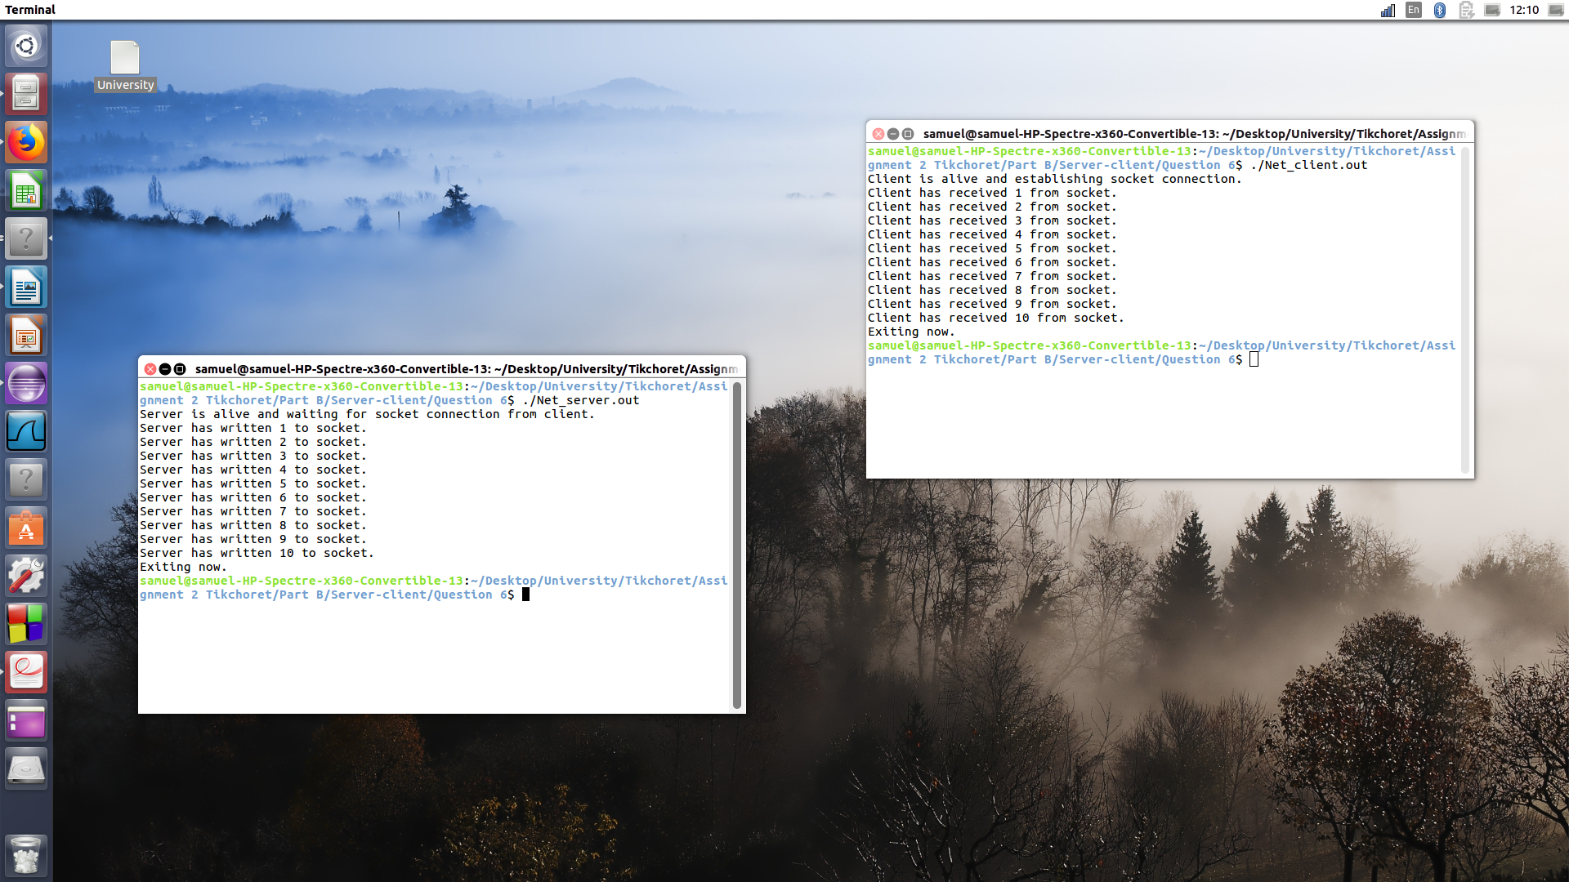
Screen-shot when running the Net_client and Net_server.

We need to run first Net_server, which contain a infinite loop (he is waiting for the client).
Then, we need to run the Net_client, and next appears like the picture shows.
Explanation : once the client is running, the server detecting him, and then, sends him 10 messages, which are the numbers from 1 to 10.
When the server sends the message, (the numbers) he is also print :
"server has written (number) to socket.”.
Then, the client receives the data from the server, and for every number print :
“Client has received (number) from the socket.”.
Important note : when we run the program of the client, we do not need to write the ip address because we already put him into the code. (protocol tcp).
Before to run the code, please refer to the README file.

Question 7 -
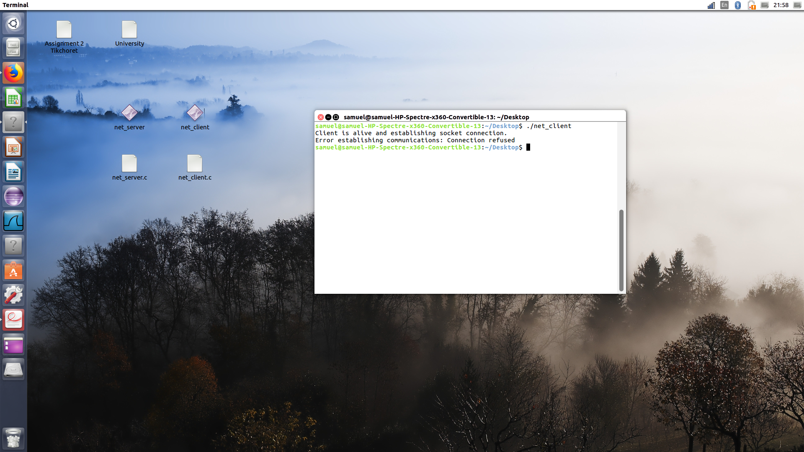
Screen-shot when running the Net_client.

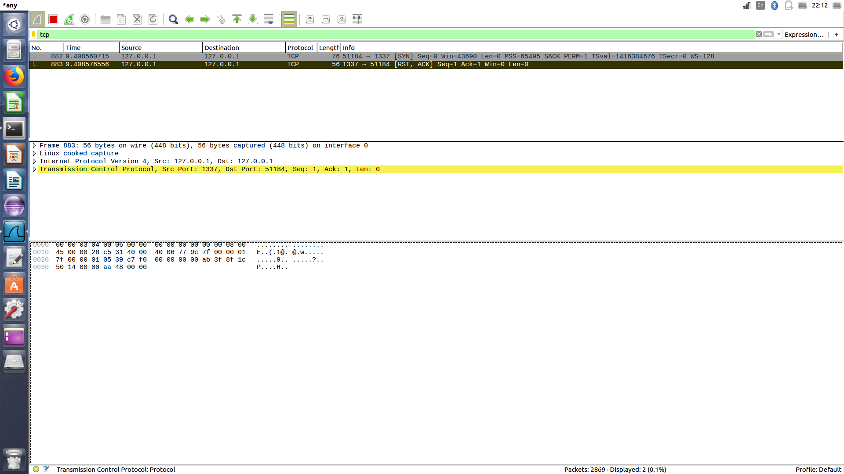
Screen-shot from Wireshark.

When we run the client without the server, we got the error message as follow : “Error establishing communications: Connection refused.”
That is because, the client try to connect at this line from the code : “if (connect(sock, (struct sockaddr *)&cli_name, sizeof(cli_name)) < 0).”.
The “if” allow us to check if we can connect, if the connect function returns -1, that mean a problem.
So we got a problem, which is the next :
The port we need to connect is not available, as shows the wireshark screen-shot.
Explanation about what we see in the picture of wireshark :
We are interested by three things : the first is "SYN" at the first line, that mean that we ask for a port.
Then we see ACK which means literally acknowledge, ie, we got the asking.
Finely RST which mean the port is not available.

Question 8 -

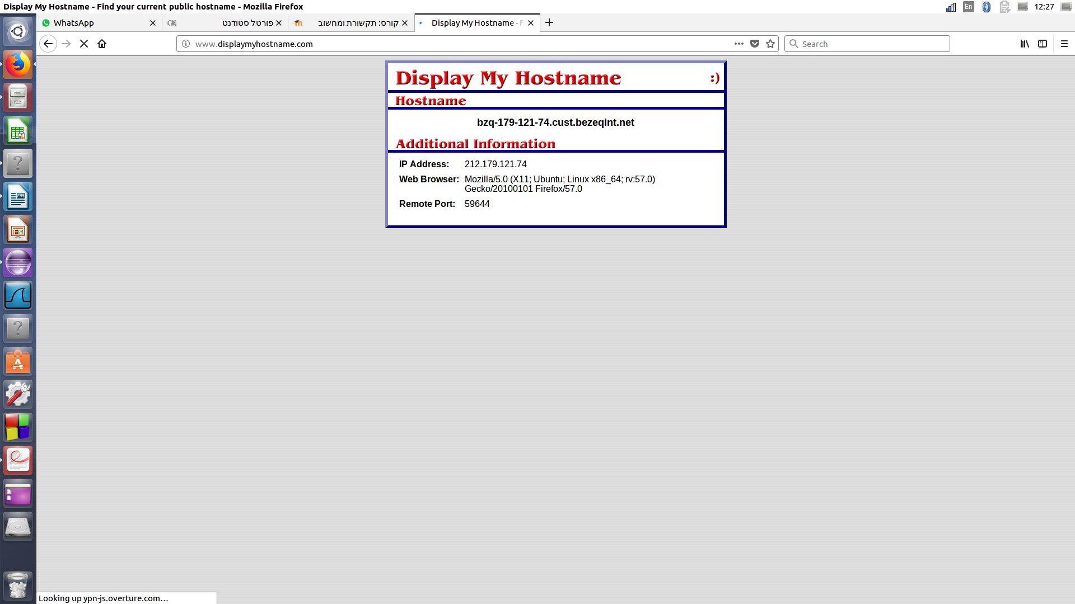
Screen-shot from displaymyhostname.

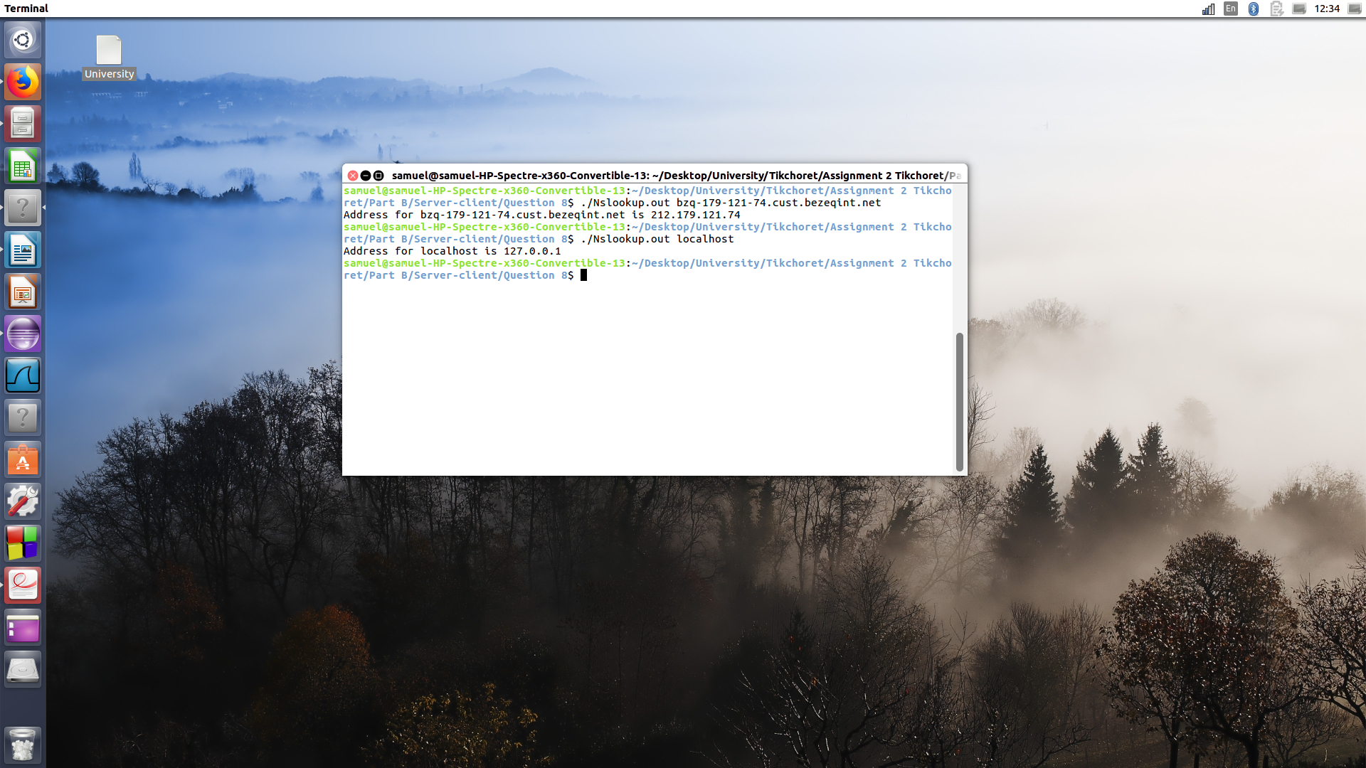
Screen-shot when running Nslookup.

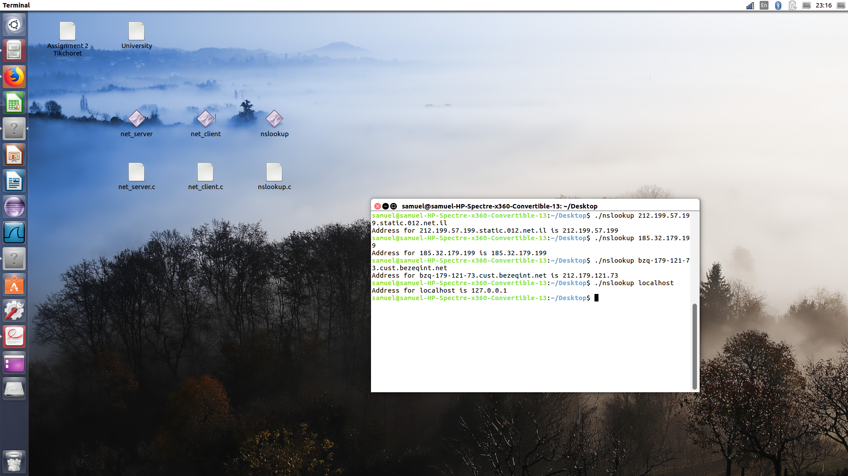
Screen-shot when running Nslookup.

As we can see, when running Nslookup passing the hostname as a command line argument, we get the ip address.
Before to run the code, please refer to the README file.

Question 9 -
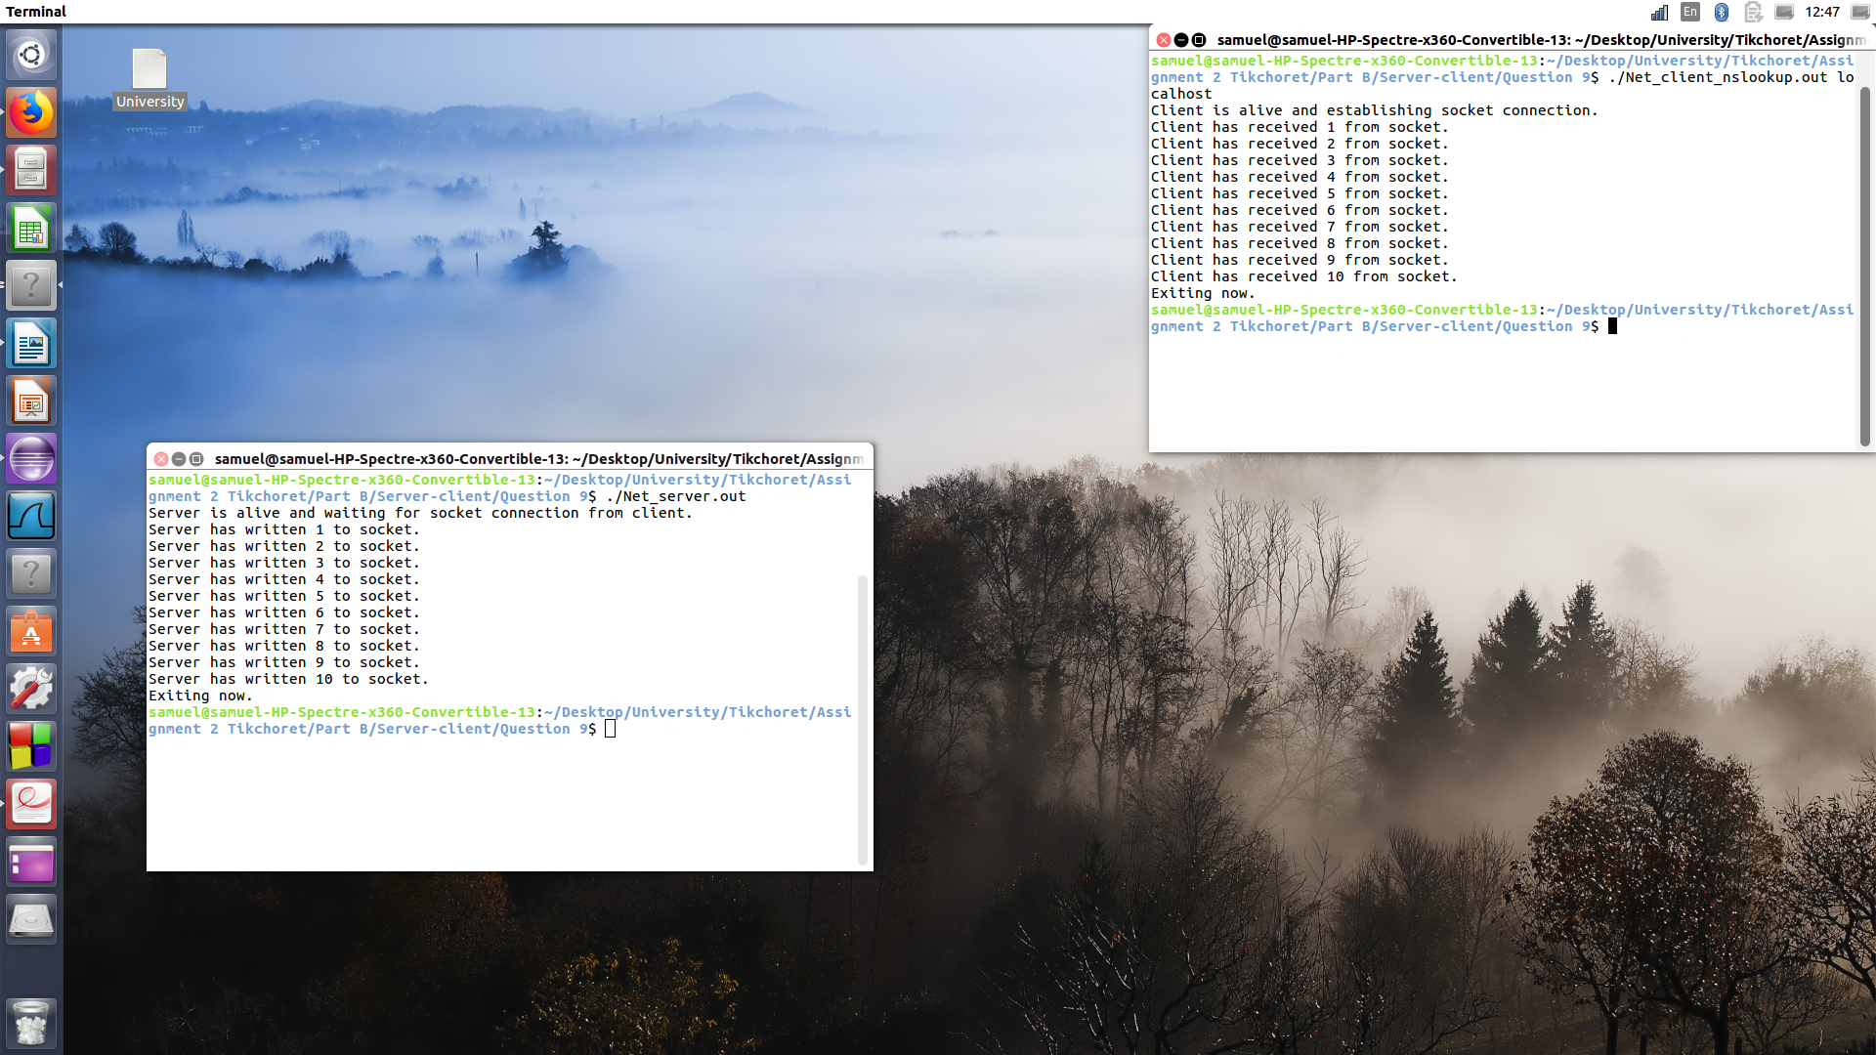
Screen-shot when running Net_Client_nslookup and Net_server.

As we can see, when running the programs, appears the same that what appears in the question 6. The only difference, is that we use the nslookup function.
To do this, the user need to input his hostname as a command line argument, and thanks to nslookup, the program is able to get the ip from the hostname. Then, the program can make a connection with the sockets, and so, able to send, and read messages.
Before to run the code, please refer to the README file.

II – Wget.

Question 1, 2, 3 -
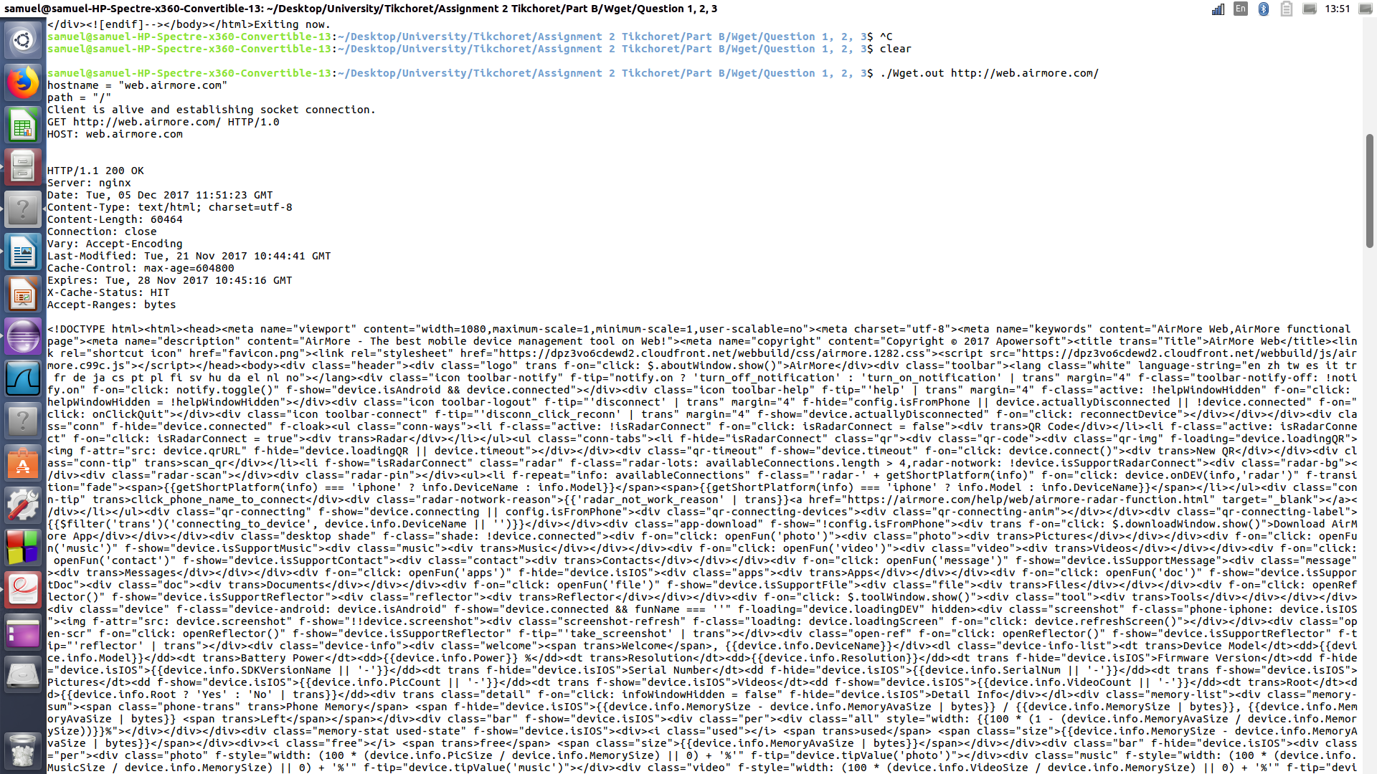
Screen-shot when running Wget with the url : “http://web.airmore.com/”.

As we can see, in the picture, there are three main paragraph.
The first is a print from the code Wget. The hostname, the path, and the request. Attention, the request needs to appears like ask in the assignment :
GET url HTTP/1.0↵
HOST: hostname↵
↵
Then, this specify request is send with the help of the socket we built.
The response of the server begin with the header.
In the header we can see all the informations related the protocols. More details will be give in the question 6.
Finely, we can see the doctype html, which is the code html of the page we ask for.
The result of the code Wget is in the folder of the question : “result.html”.
Before to run the code, please refer to the README file.

Question 4 -
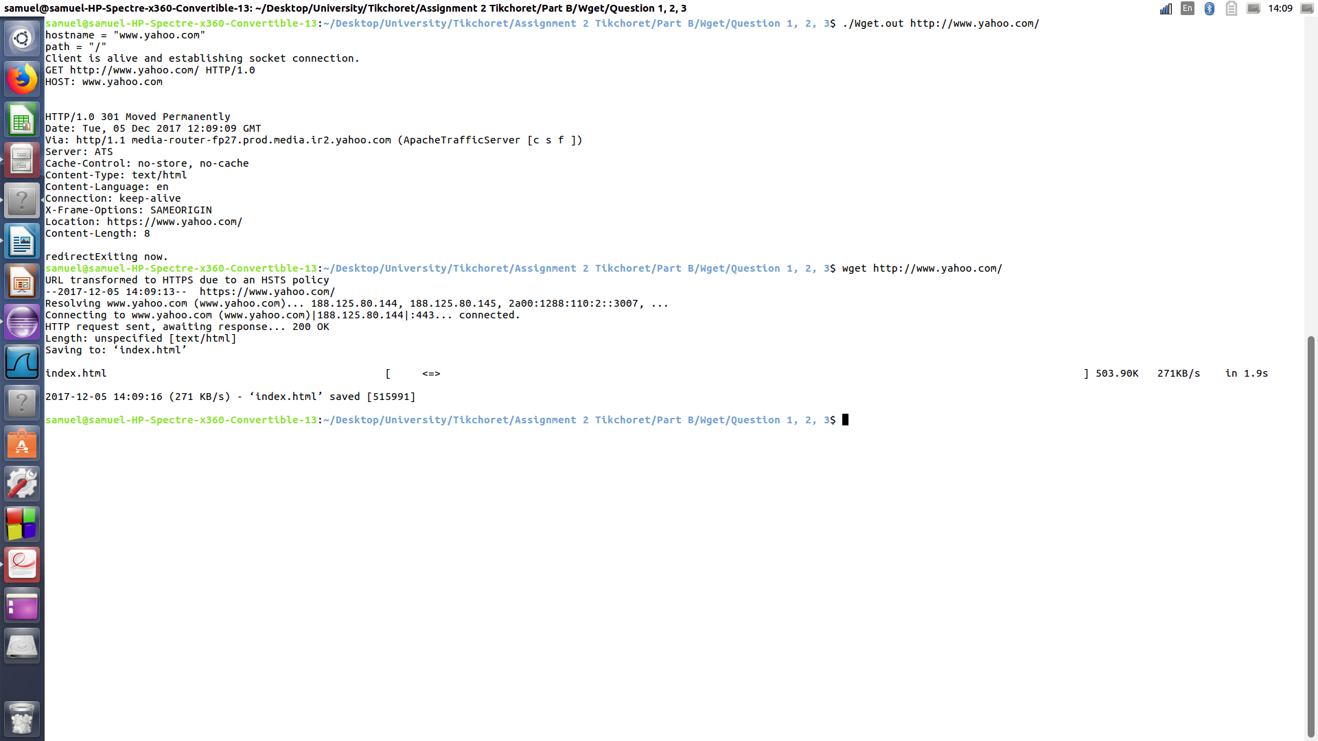
Screen-shot when running Wget we built, and from the linux terminal, with the url : “http://www,yahoo.com/”.

When running Wget we built with the url http://www.yahoo.com/, we receive the header. :

HTTP/1.0 301 Moved Permanently
Date: Tue, 05 Dec 2017 13:06:16 GMT
Connection: keep-alive
Via: http/1.1 media-router-fp7.prod.media.ir2.yahoo.com (ApacheTrafficServer [c s f ])
Server: ATS
Cache-Control: no-store, no-cache
Content-Type: text/html
Content-Language: en
X-Frame-Options: SAMEORIGIN
Location: https://www.yahoo.com/
Content-Length: 8

In this header, there is a message : “301 Moved Permanently”.
That means that this url has moved, ie, from http to https. Indeed, after verification, yahoo moved and the url we put doesn’t exist.
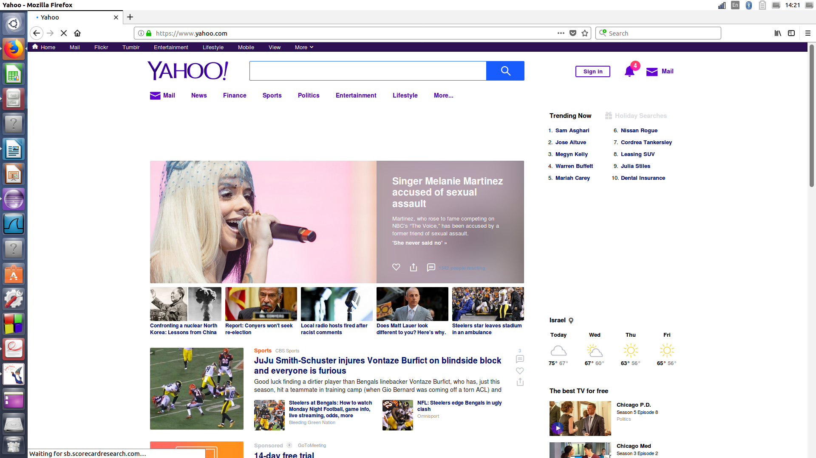
Screen-shot of the site yahoo. We can notice https.
And also, the wget of linux confirm us this theory, because as we can see in the picture, the url has moved from http to https.

Moreover, the header show us the date of the server’s place.
The connection controls whether the network connection stays open after the current transaction finishes : keep alive.
Via : added by proxies, both forward and reverse proxies.
The server : ATS.
Cache-Control : specifies directives for caching mechanisms in both requests and responses.
Content-Type : indicates the media type of the resource.
The language : english, the location…
X-Frame-Options : indicates whether a browser should be allowed to render a page.
The location : indicates the URL to redirect a page to.
Content-Length : indicates the size of the entity-body, in decimal number of octets, sent to the recipient. Here it’s 8.

Question 5 -
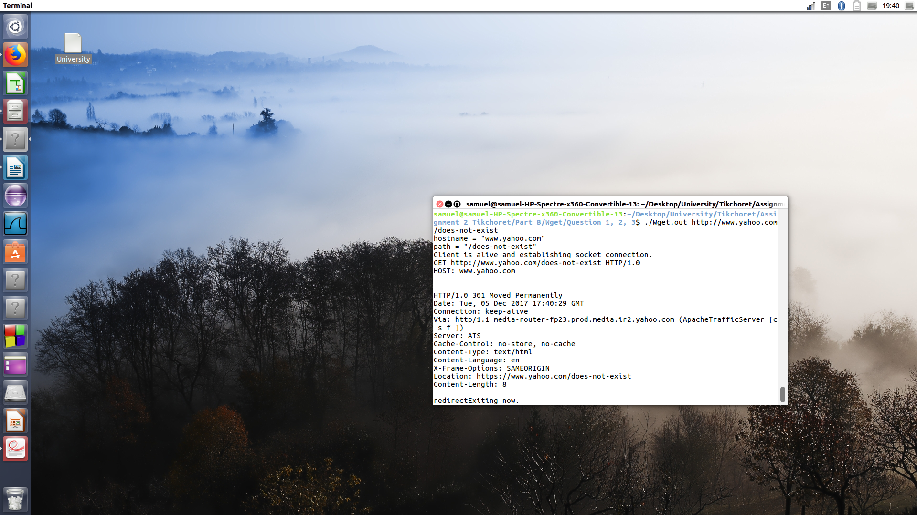
Screen-shot of header to response of the request to yahoo/doest-not-exist.

Because yahoo is now an https address, the header doesn’t change with or whit the “/does-not-exist as we can notice in the picture.

But, I tried to run the code with an http address as follow :
http://www.agcocorp.com/
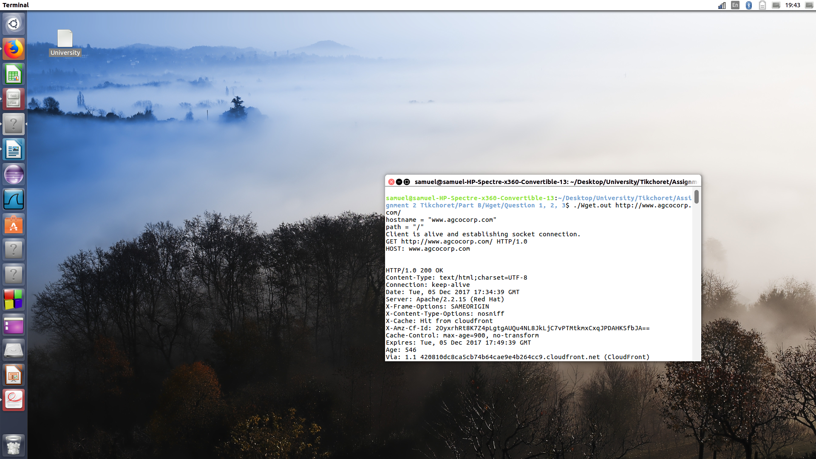
Screen-shot of header to response of the request to http://www.agcocorp.com/.

And it’s give us the next header :

HTTP/1.0 200 OK
Content-Type: text/html;charset=UTF-8
Connection: keep-alive
Date: Tue, 05 Dec 2017 17:34:39 GMT
Server: Apache/2.2.15 (Red Hat)
X-Frame-Options: SAMEORIGIN
X-Content-Type-Options: nosniff
X-Cache: Hit from cloudfront
X-Amz-Cf-Id: 2OyxrhRt8K7Z4pLgtgAUQu4NL8JkLjC7vPTMtkmxCxqJPDAHKSfbJA==
Cache-Control: max-age=900, no-transform
Expires: Tue, 05 Dec 2017 17:49:39 GMT
Age: 546
Via: 1.1 420810dc8ca5cb74b64cae9e4b264cc9.cloudfront.net (CloudFront)

That’s mean briefly that everything ok.

And this is the result when we run with the next address :
http://www.agcocorp.com/doest-not-exist/
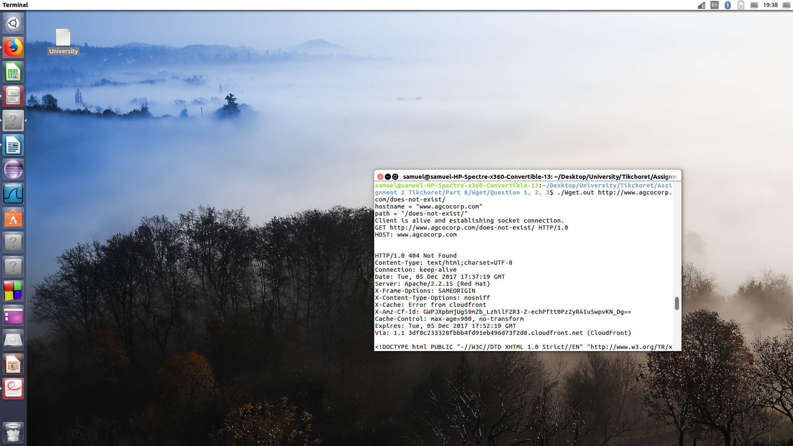
Screen-shot of header to response of the request to http://www.agcocorp.com/doest-not-exist.

And the header as follow :

HTTP/1.0 404 Not Found
Content-Type: text/html;charset=UTF-8
Connection: keep-alive
Date: Tue, 05 Dec 2017 17:37:19 GMT
Server: Apache/2.2.15 (Red Hat)
X-Frame-Options: SAMEORIGIN
X-Content-Type-Options: nosniff
X-Cache: Error from cloudfront
X-Amz-Cf-Id: GWPJXpbHjUgS9mZb_LzhilF2R3-Z-echPftt0Pz2yRAIu5wpvKN_Dg==
Cache-Control: max-age=900, no-transform
Expires: Tue, 05 Dec 2017 17:52:19 GMT
Via: 1.1 3df8c233328fbbb4fd91eb496d73f2d8.cloudfront.net (CloudFront)

We can notice the line : HTTP/1.0 404 Not Found.
This line means that there was a problem with the request. Indeed, we input on purpose the “/doest-not-exist.

Question 6 -
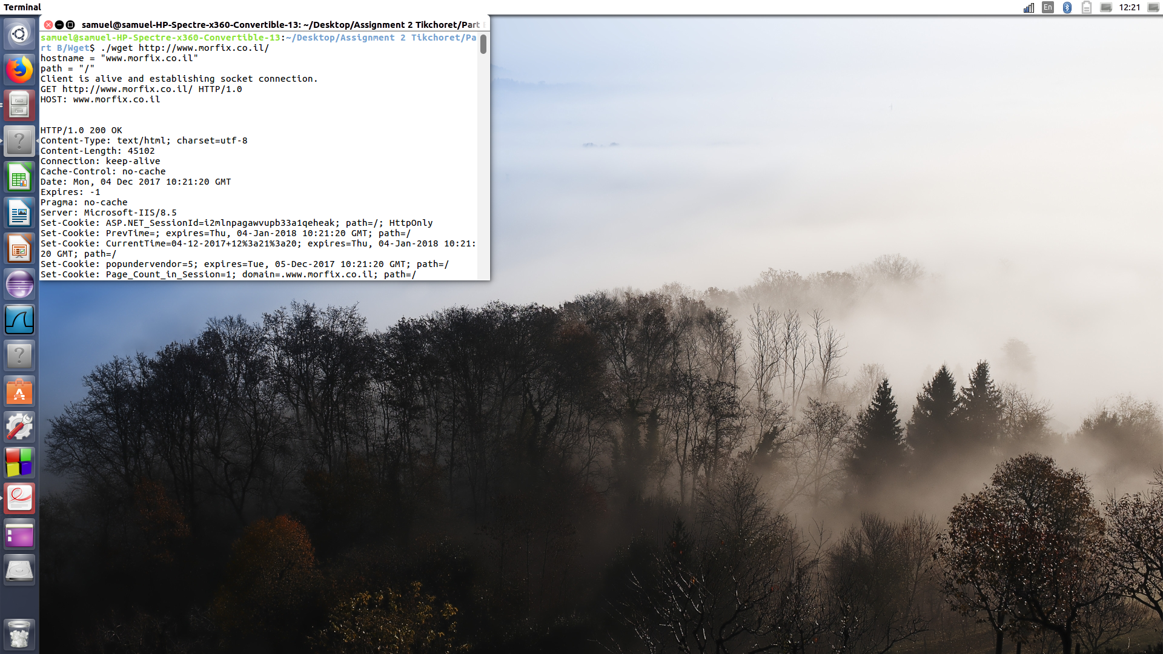
Screen-shot morfix.

Here we got 200 ok, that’s mean the request has succeeded.

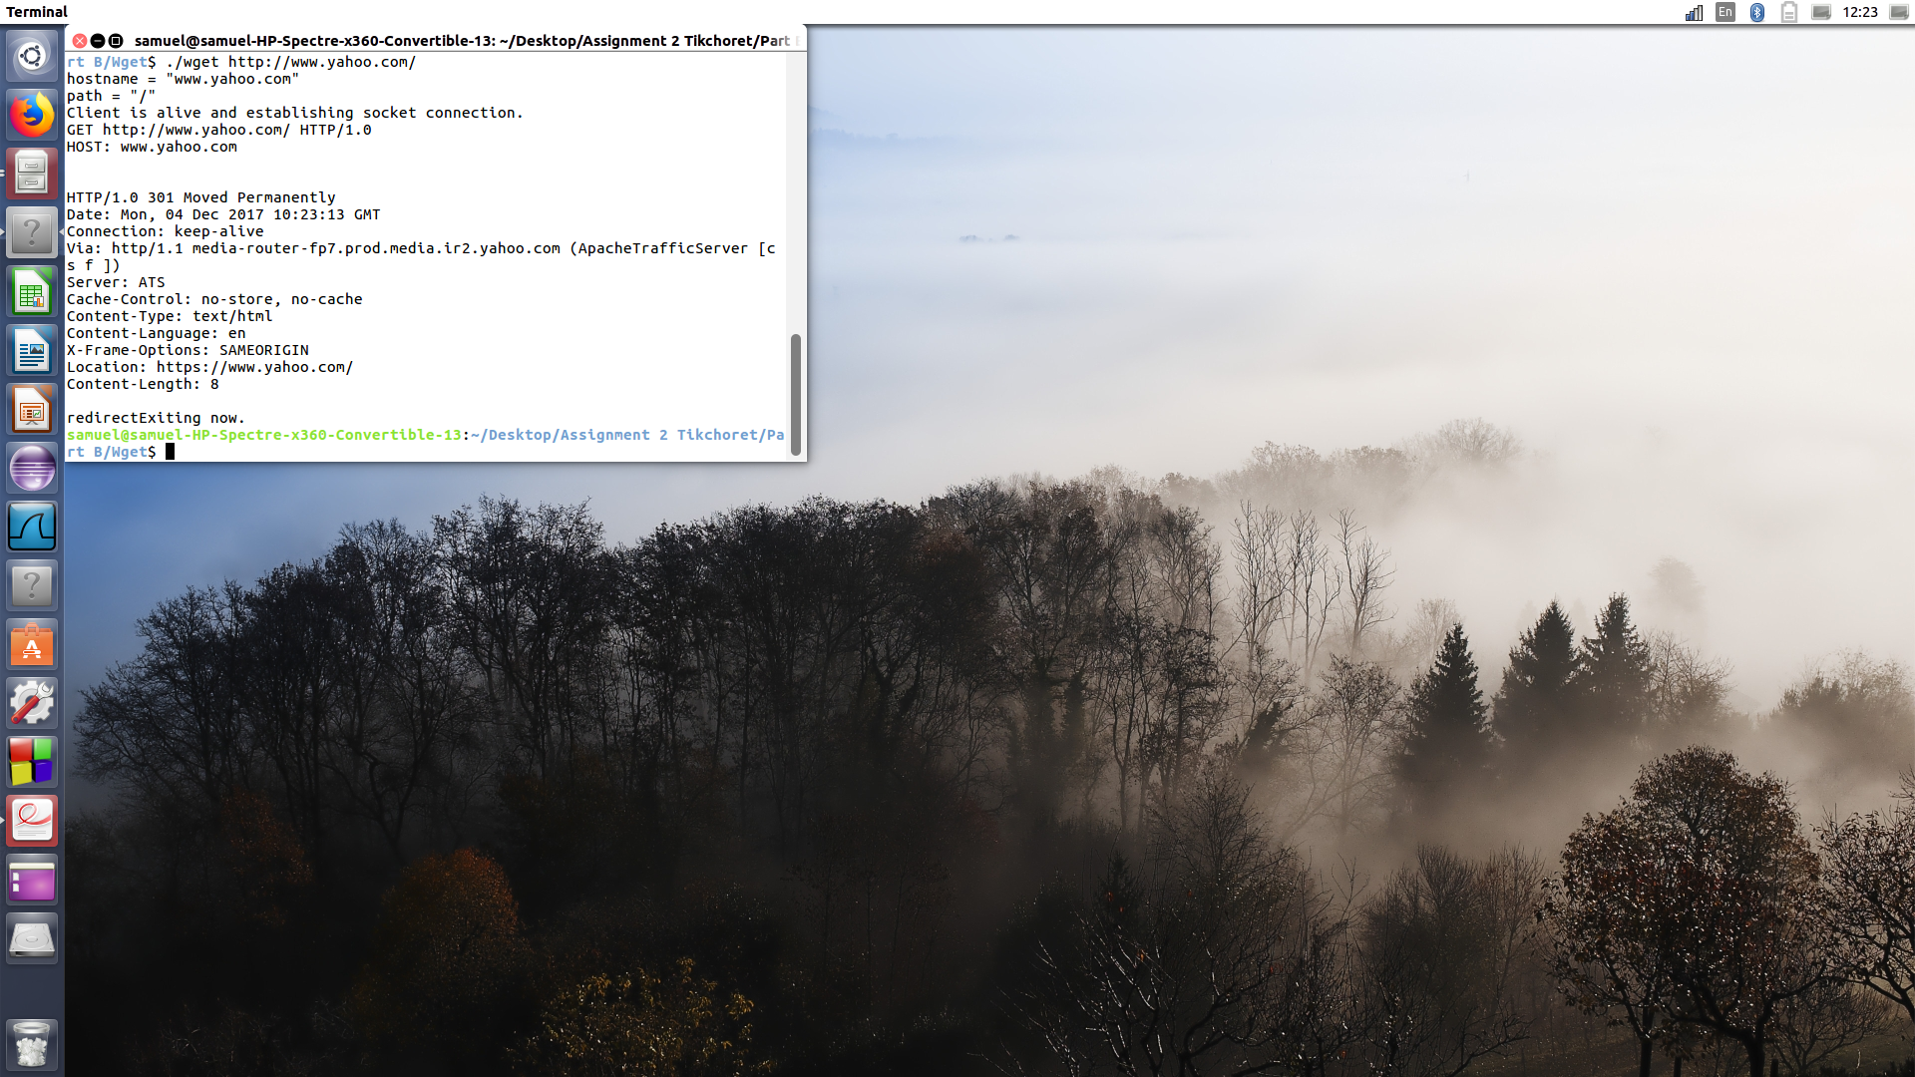
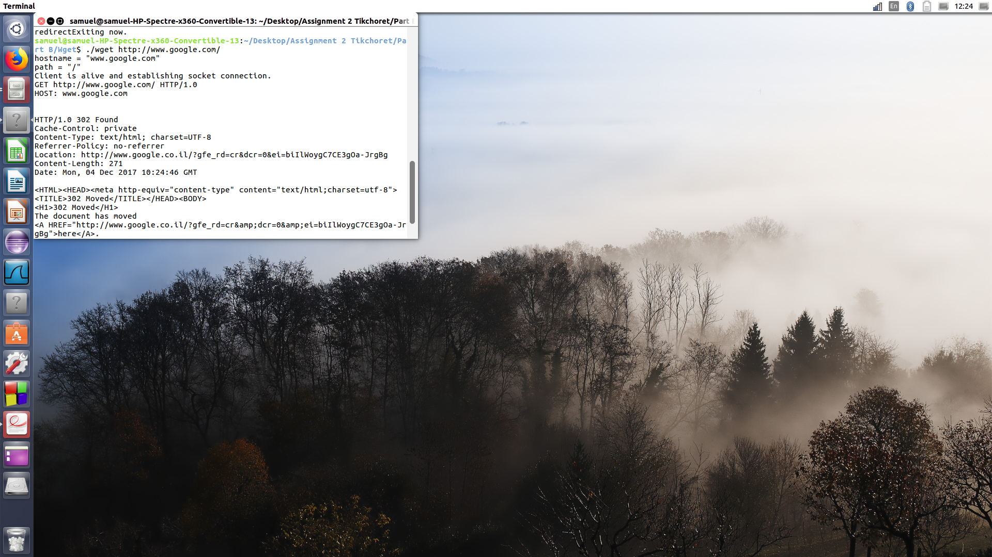
Screen-shot google.

Here we got 302 Found that’s mean : The requested resource resides temporarily under a different URI. Since the redirection might be altered on occasion, the client SHOULD continue to use the Request-URI for future requests. This response is only cacheable if indicated by a Cache-Control or Expires header field.
This is because google use an https protocol.

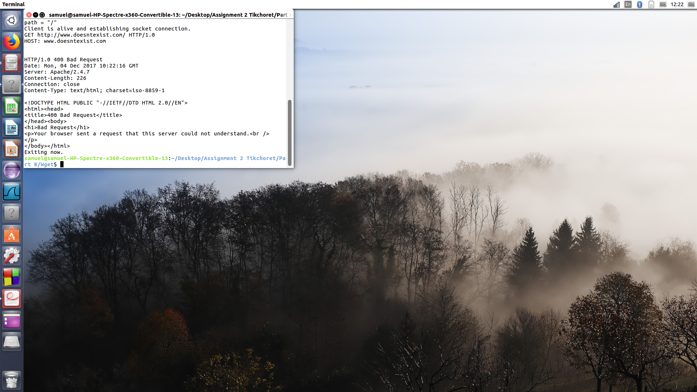
Screen-shot request doesn’t exist.

Here we got a 404 not found message.
The server has not found anything matching the Request-URI. No indication is given of whether the condition is temporary or permanent. This status code is commonly used when the server does not wish to reveal exactly why the request has been refused, or when no other response is applicable.

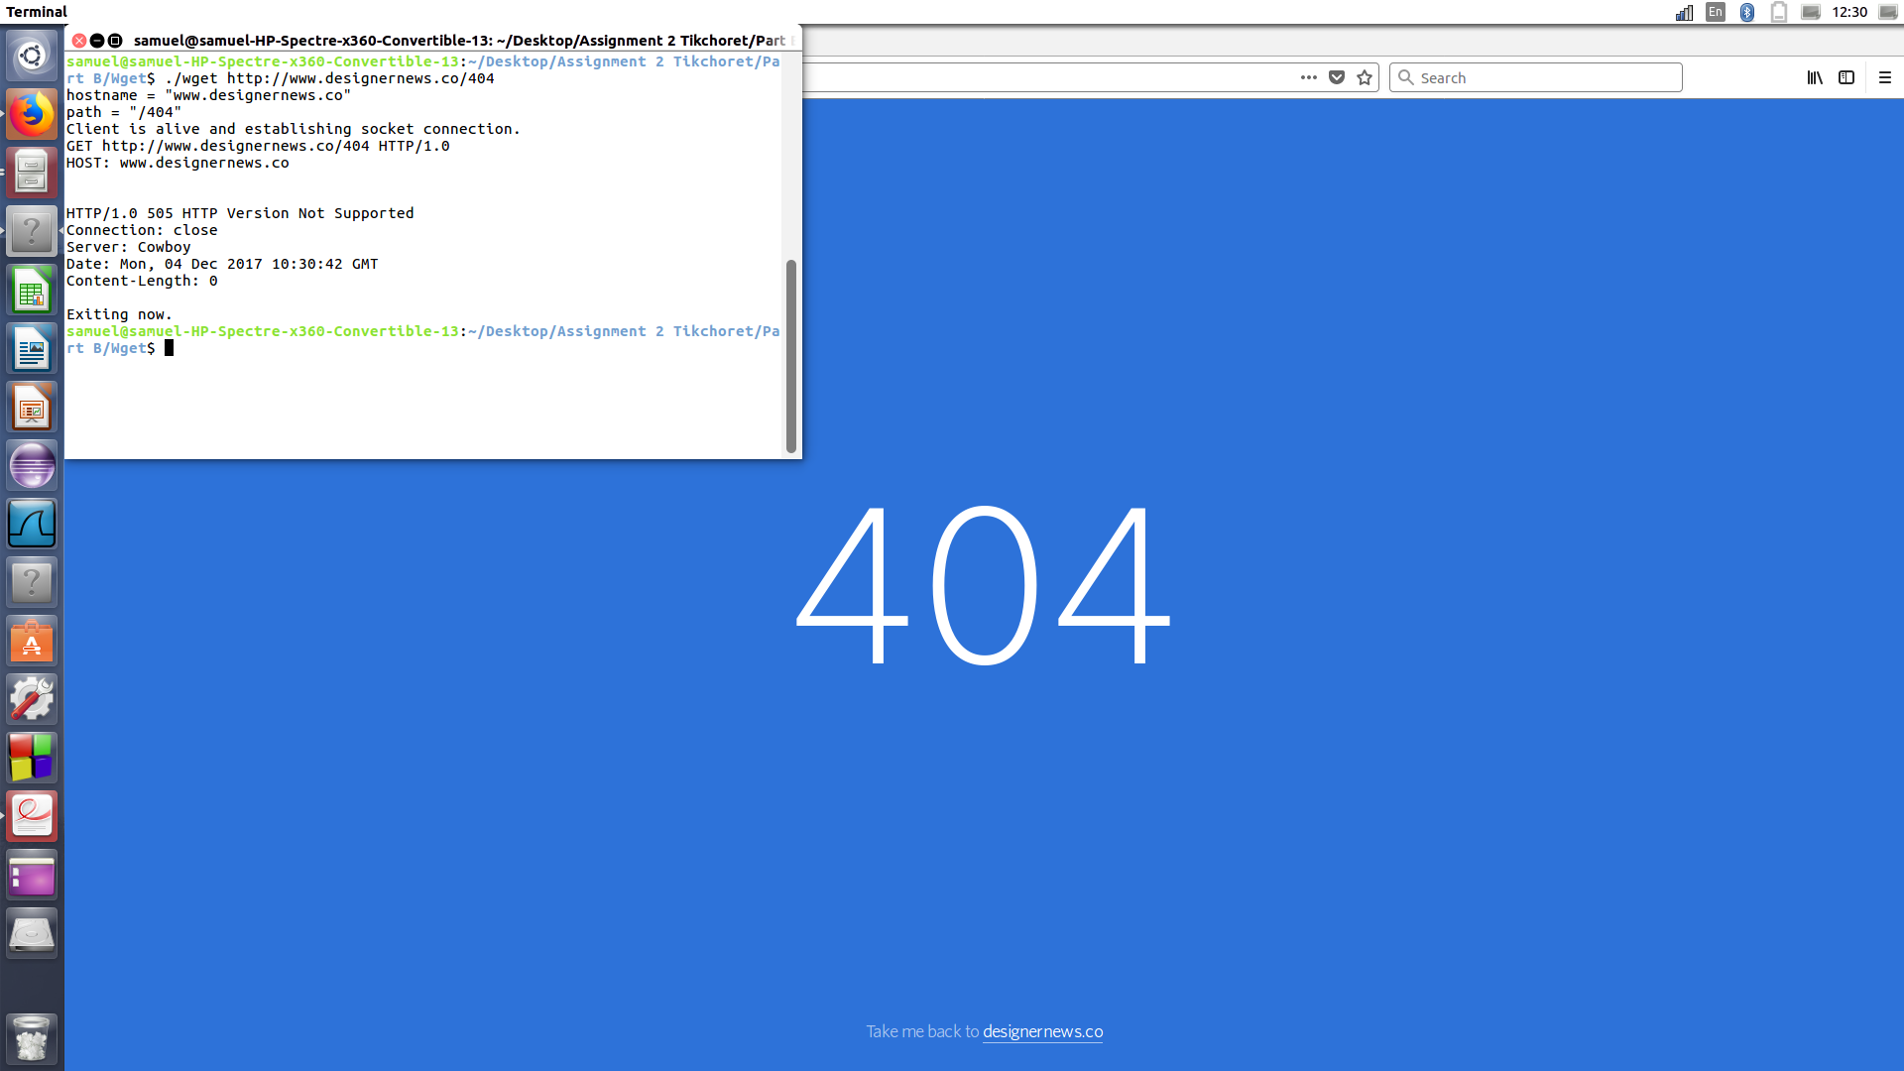
Screen-shot request which turn into a 404 not found page.

We got a 505 message : HTTP Version Not Supported.
The server does not support, or refuses to support, the HTTP protocol version that was used in the request message.
It’s funny to see that the “404 not found” message could be 500’s message.

Screen-shot request yahoo with http protocole.

We got a 301 Moved Permanently message :
The requested resource has been assigned a new permanent URI and any future references to this resource SHOULD use one of the returned URIs. Clients with link editing capabilities ought to automatically re-link references to the Request-URI to one or more of the new references returned by the server, where possible. This response is cacheable unless indicated otherwise.

